**

**MIDDLE EAST TECHNICAL UNIVERSITY**

**Electrical & Electronics Engineering Department**

**EE494 - Engineering Design II**

***“Cısss!”***

***Critical Design Review Report***

**Company Name:** Lambda

**Starting Date of the Project:** 18.10.2021

**Completion Date of the Project:** 16.06.2022

**The Project Duration:** ~ 8 Months

**Members of Company :**

1. Berk Erhan Yüksel
2. Necdet Can Sönmez
3. Mustafa Barış Emektar
4. Alper Saraç
5. Furkan İtkü

**Design Coordinator :**

* Associate Professor Dr. Elif Vural

**Table of Contents**

**Executive Summary** **3**

**Introduction** **4**

**Overall System** **5**

System-Level Flowchart 10

Subsystems 11

Detection Subsystem 11

Control Subsystem 12

Alerting Subsystem 15

Prior Test Processes 17

Test Procedures 17

Experiments 17

Test Results 20

**Requirements** **24**

**Management** **25**

Cost Analysis 25

Power Analysis 26

Deliverables 27

**Test Plans** **28**

Test Plan for Detection Subsystem 28

Test Plan for Control Subsystem 28

**Compatibility Analysis of Subblocks** **29**

**Compliance with Requirements** **29**

**Conclusion** **31**

**References** **32**

**Appendix** **33**

Gantt Chart 33

### Executive Summary

"Cısss!" is the name of the product that will be presented. It is smart equipment that aims to make pet parents' lives simpler. The device is made up of two parts: a master unit and a number of tags. The master unit is a wearable smart gadget that detects the presence of tags nearby and warns the wearer (the pet) of any misdeed. To "mark" it as forbidden, the tags can be put in open spaces as well as entrances up to 90 cm wide. The device notifies the pet when it approaches the restricted zone without harming it. The master unit is small and safe for the animal, causing no discomfort or injury.

The device is currently in development, and a prototype has been built for testing reasons. The prototype is made up of two CC2640R2 evaluation boards that serve as the master and tag. The two boards interact using radiofrequency wave radiation, and the master unit calculates the tag's distance using the wave's received signal strength indication (RSSI) value. The estimated distance is used to determine “the state of proximity” of the master and the tag. The observer is notified of this state through the on-board LEDs, since the buzzer is yet to be implemented. If desired, the estimated distance, RSSI value, or any other intermediate values may be communicated via UART to a connected computer and seen as a real-time graph. Using the data acquired, the relevant parameters were fine-tuned to achieve the best result possible. Moreover, problems with the current state of the device were identified, and contingency plans on how to fix these were created. In the next stage of development, a PCB design will be made, using CC2640R2 microprocessors. The PCBs will replace the evaluation boards. This is so that the final device is compact and cost-efficient.

This report presents how the previously proposed solution to the problem is going to be implemented. The system designed for the implementation is presented in a top-down approach, with the entire system given first and then the details about each subsystem being given next. The progress currently made, and the valuable information gained during that progress is discussed. The test procedures that were followed to gain that information, as well as the possible problems in the system that were uncovered during those tests are given. Contingency plans on how to tackle these problems are also talked about. Power consumption and hardware cost of the device are analyzed, followed by the expected deliverables. Future test plans, as well as details of the compliance of the current state of the device to the requirements, are presented last.

### Introduction

Many people nowadays live with their pets in their houses. They treat their pets as if they were children, and they do not keep them separate from their families. On the other hand, these pets may be as naughty as they are cute at times. They might leave the house by going out the front door, or they could climb the kitchen counters to eat something they shouldn't. Therefore, by preventing these misbehaviors, pet parents need a tool to keep their pets from injuring themselves or creating a mess. This is where Lambda comes into play.

Lambda is proud to present a revolutionary product that aims to prevent dogs from engaging in potentially dangerous behavior, which is a considerably big gap in the market. The offered product is meant to be worn on the pet's collar, but due to the device's tiny form, clients may have their dogs wear it anywhere they choose. The main device, referred to as the "master unit," is designed to be as small and light as possible to avoid causing discomfort to the wearer. The master unit, however, is not the only component of the product. The product also comes with tags that can be placed wherever in the house that the user wants to mark as "forbidden." If the pet trespasses or approaches certain prohibited areas, the master unit will alert the pet without harming it. The intended alerting mode is acoustic and vibrational. Given that thousands of pet owners deal with the concerns listed regularly, it's obvious that a device that can prevent harmful behavior in animals without injuring them has enormous market potential.

The document you are going to read is the stated product's critical design review report, which is a technical report ensuring that the system under review can proceed to system fabrication, demonstration, and test; and can meet the stated performance requirements within cost (budget), schedule, and other system constraints, and relevant standards. The system's critical components, such as RSSI measurement for detection, Kalman filtering, and using a buzzer for alerting, will not change after this report.

### Overall System

Overall system is divided into three subsystems, and the system level flowchart is presented for a better understanding of the structure. In this section, firstly, the overall system block diagram and the objectives are given. After that, the system-level flowchart and each subsystem are explained in detail with **exact** solution methods. At the end of the section, test results are provided.

As indicated in the above sections, the company aims to design a compact, low-cost product with low power consumption. However, there is a trade-off between these objectives. Therefore, the company’s objectives for this project are as follows:

* If the pet crosses the predefined boundary of the tag, it will be warned **in at most a second.**
* The product will be able to sense four different distance ranges to **warn the pet in four stages of increasing alarm strength**.
* The dimensions of the master unit need to be as small as possible since the pet will be wearing it. Therefore, the **dimensions must be at most 15cm x 10cm x 7 cm**. The product's shape can vary; it does not have to be a rectangular prism. A simple concept of the devices has shown in Figure 3.1.
* There is no metric for the stability of the project, but **the system needs to be as stable as possible**. For example, if the pet is stationary but the system switches between alerting and non-alerting modes, that means the system is not stable as desired.
* Since the device's wearer is a pet, it **should not weigh over 100-150 grams.**
* Both the master unit and the tags should be able to be powered with a **single-button battery**, which will be able to keep it powered up for **at least two weeks**.

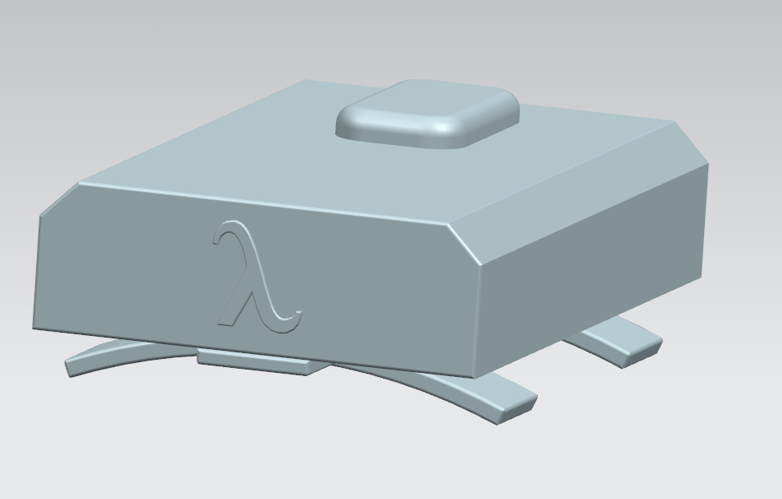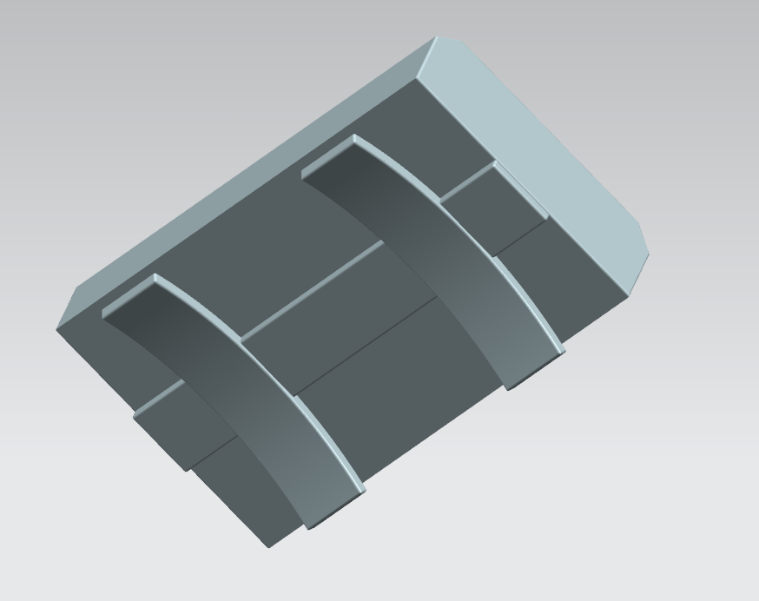

**Figure 3.1** *Proposed design of the master unit case*

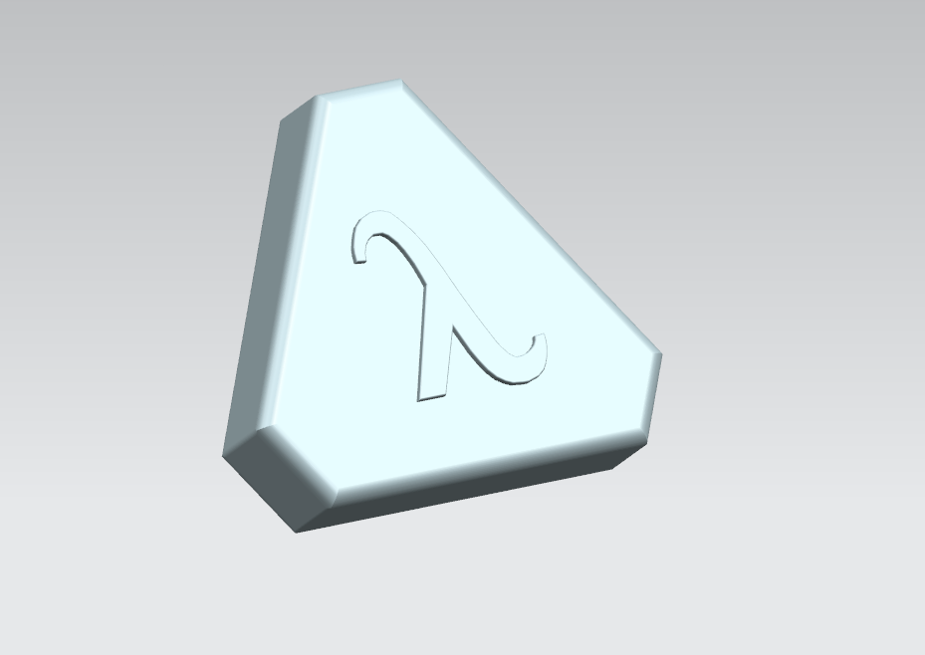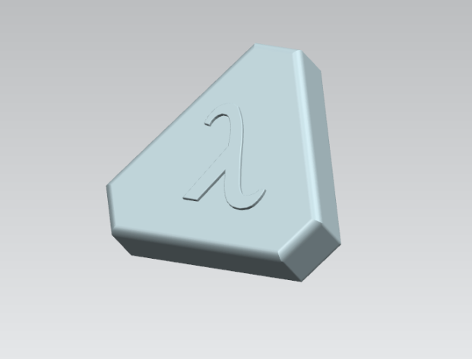

**Figure 3.2** *Proposed design of the tag case*

Note that these drawings are purely a concept & during the integration process, these designs may change according to the test results obtained during the optimization phase of the project.

The working principle is quite straightforward. The detection system detects the presence of a tag (or the master) being in proximity, and starts communicating over RF. The communication between the units allows the control subsystem to deduce the estimated distance between the units based on the strength of the signal received. Depending on the computed distance estimation, the control subsystem informs the alerting subsystem to adjust its alerting strength accordingly if need be. Finally, the alerting subsystem warns the pet by causing a sound and vibrating.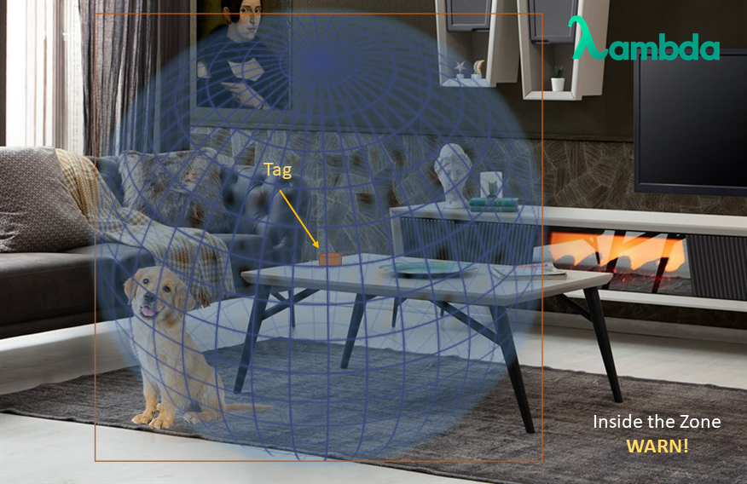

**Figure 3.3** *Representation of the animal being inside the forbidden zone*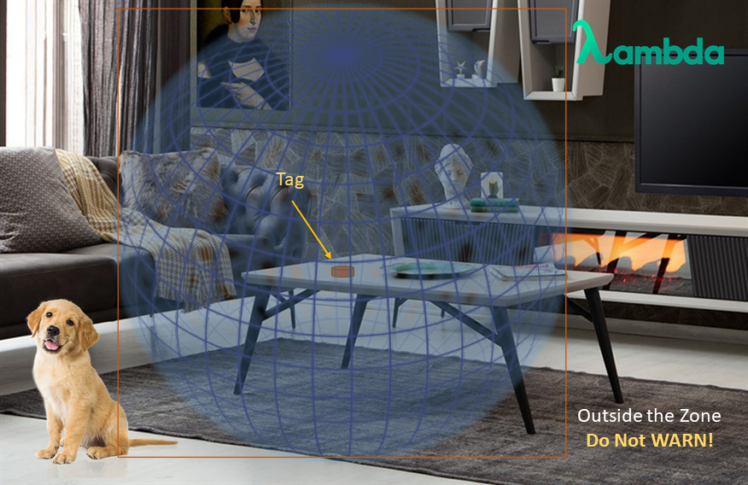

**Figure 3.4** *Representation of the animal being outside the forbidden zone*

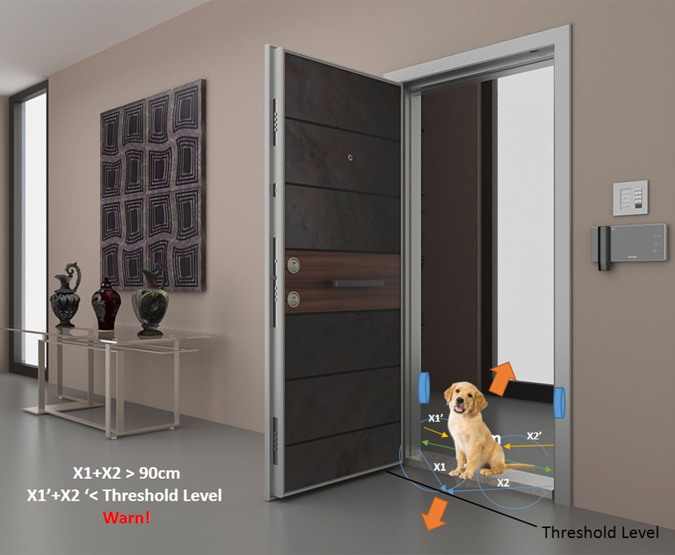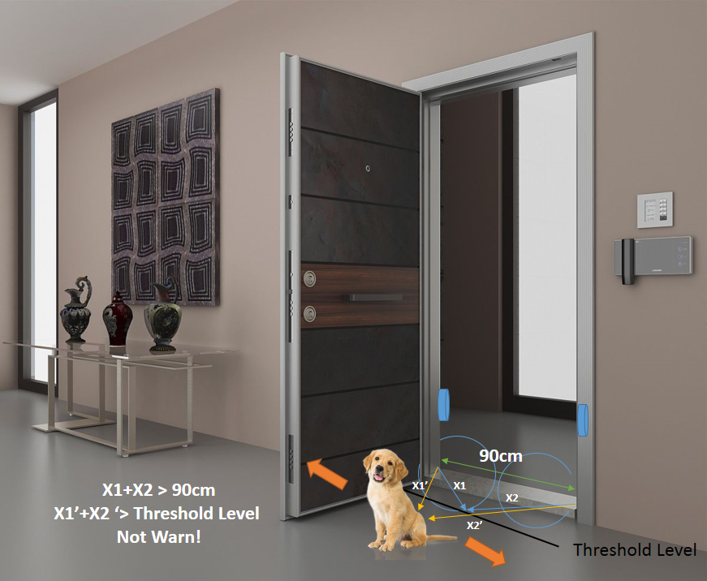

**Figure 3.5** *Door tag explanation* **Figure 3.6** *Explanation continued*

$$X_{1}and X_{2} : Angular distance of two tags to the specified threshold level$$

$$X_{1}'and X_{2}' : Angular distance of two tags to the main tag (pet)$$

The figures above show our current plan of differentiating a doorway forbidden zone from a zone tag. The working principle of the zone tags is simply the above-explained method where a distance estimation is calculated to determine the alerting output. In a doorway zone, two tags will be placed in close proximity to one another, as seen in the figure. Ideally, the tags will be placed on the left and right boundaries of the doorway to simplify the algorithm. Both distances will be calculated to then be compared to a threshold value. As stated in the figures above, a summation may be done with these values to decrease complexity. A more sophisticated approach may be utilized to increase the accuracy. However, this may increase our reaction time and/or increase power consumption.

This doorway tag system may be too expensive for the project's scope if we fail to switch to a custom PCB design for our tags. We intend to use a custom PCB since this would decrease the size of the tags and decrease our costs drastically. Currently, CC2640R2 Launchpads are used for the development process as they are easy to work with. However, they are not optimal to be included in a finished product. Since there is a non-zero possibility of using these Launchpads in the final product due to some circumstances, we believe it is best that we prepare for the worst-case scenario. To implement the doorway tag system, the following logical statements can be followed.

* Switching to a PCB-based system ***implies*** being able to obtain more tags inexpensively.
* ***If*** it is possible for us to obtain three or more tags, ***then*** the above-mentioned 2-tag system will be implemented.
* ***Else if*** the design of the proposed system that uses one tag for the doorway system (explained in the “Detection Subsystem” part of the report) is robust enough, ***then*** the implementation will be in accordance with that system.
* ***Else***, the doorway will be treated as another zone, and the implementation will not try to differentiate between them.

Note that in all of the cases presented above, the system will theoretically deter the animal from getting near the tag. In a worst-case scenario, the system will still be able to do that. The cases stated above the others are simply better implementations.

#### System-Level Flowchart

**Figure 3.7** *Operational Flowchart*

#### Subsystems

The overall system consists of three subsystems: the detection subsystem, the control subsystem, and the alerting subsystem.

##### Detection Subsystem

The details of “What should the detection subsystem do?” were presented in CDR. In this report, the specifics of our application will be presented.

The previous research and development focused on using RF communication in 2.4GHz and measuring the received signal strength indicator (RSSI) from each transmit-receive event. As explained in the “Control Subsystem” part of the report, the tag received a signal from the master unit and responded with another signal. The master unit then receives this signal to measure the RSSI value.

The team finds it more intuitive to work on the zone tags first as determining the distance, or determining the distance interval, from the master unit to the tag will result in a working zone tag system. If we were to implement a door tag in the future, it might operate much similarly to a zone tag, as the doorway can be considered a forbidden zone. If the master unit has to know whether the tag is a door tag or a zone tag, using more than one tag for the hallway at specific locations would allow us to differentiate between a zone and a hallway.

In addition to using multiple tags, the antenna's properties may be useful for us to establish the difference between a zone and a doorway tag. In the tests done previously, the team observed that the PCB antennas in the system obtained larger measurements if the antennas were pointing towards each other. Theoretically, one can use this property to create the differentiation between zone and doorway tags in the following way. For the zone tags, the tags will point away from the wall. For the doorway tags, the tags will be parallel to the doorway i.e., parallel to the wall. The RSSI values measured from these cases will differ as the antenna angles and the signals that reflect off the wall will be different. The applicability of this will be determined throughout this process. An if-then table will be added to the end of this section to list the possible outcomes in each case.

The project will use RF signals and RSSI measurements since the final product should have close to no interference with objects as opposed to some of the other methods that were described in CDR. Obtaining RSSI measurements is simple and cost-effective. There are many other methods with higher accuracy. However, implementing those systems on a device that needs to fit a possibly small pet is not an option in this project's scope and budget. These are the main reasons why we chose to use RSSI measurements for the detection subsystem.

##### Control Subsystem

For the control subsystem, the CC2640R2 microprocessor was chosen. This microprocessor is a part of TI’s “SimpleLink” series, which was designed for over-the-air communication implementations through 2.44 GHz RF waves, which is perfect for our case. This microprocessor was selected because this is the cheapest one of the series and gives us the performance we desire, nonetheless. Furthermore, TI provides its users with an open-source framework to make project development easier, which some team members are familiar with.

TI sells CC2640R2 in two forms, one being in just the microprocessor form and one as an evaluation board. The evaluation board is a pre-built PCB, with all the board's capabilities ready to be implemented should the user desire. The evaluation board is rather expensive compared to just the microprocessor itself but allows the developers to easily experiment with the chip and see what can be done. For this reason, the evaluation board was preferred for the R&D stage. However, the plan is to design our PCB using the microprocessor. This will cut down significantly on the price. Until the hardware designs are finalized, however (or in a nightmare scenario where time does not allow us to), the evaluation board will be used.

As for TI’s ready-to-use framework, TI-RTOS (TI real-time operating system), it provides great convenience and saves us a lot of time. However, the framework is written in C (while we prefer C++ in order to be able to use an object-oriented approach) and is quite lacking in terms of readability. As such, the given framework was abstracted under our framework, which was written in C++ with an object-oriented programming approach. This way, TI’s code is hidden, and the general structure of the code has much better readability, which we believe is vital for the whole team to be able to understand the code and contribute to it.

The firmware abstracts the peripherals as objects, such as the RF capabilities (the connection between this submodule and the detection submodule) and the UART port (vital for testing). The “application” is the main part of the code, which is the part where the main functions of the firmware are set up. Of course, the project contains a “master unit” and “tags”, so the firmware for these are separate (the tags have the same firmware between themselves). They share the same framework structure, however.

The control subsystem works like this: the master continuously transmits a signal, waiting for a tag to pick the signal up. The tag, on the other hand, continuously waits for a signal to be received. When the master and a tag find each other, they switch roles; that is, this time the tag transmits a signal, and the master picks it up. When the master receives this “acknowledgment” signal, it can process the RSSI (received signal strength indication) of the signal to determine how far the tag is to itself. [1][2][3]

In order to determine the distance using RSSI, the following formula is used:

$$distance=100*10^{(RSSI_{ref}-RSSI_{meas})/(10n)}$$

*where; RSSIref is the empirically found RSSI value for 1 meter,*

*RSSImeas is the measured RSSI value,*

*n is the propagation exponent representing the environment found empirically.*

This formula models the relationship between distance and RSSI as a logarithmic function. The distance acquired from this formula cannot be used directly, however. The noise that RSSI measurements carry are far from being negligible, and as such, the found values must be filtered first.

There are many factors to be considered for a filter. For a more robust implementation, a strong filter is required. However, a strong filter will reduce reaction speed, as many samples will need to be required for the system to drift from one state to another. This problem may be mended by increasing sampling rate, in which case power consumption will rise. Moreover, the sampling rate is limited by the hardware capabilities of the system, which are hard to change and furthermore would increase the cost.

Keeping this in mind, different filters were experimented with. The most constraining factors ended up being robustness and reaction speed. We realized that with the hardware at hand, we needed to compromise from either. We ended “giving and taking”, compromising from both to what we perceived as acceptable levels.

In our type of application, Kalman filters are widely used. A Kalman filter is a type of filter that uses the previous state of the system together with the current measurement to predict the next state of the system. The “uncertainty” of the system determines how much one should “trust” the current measurement. If the uncertainty is low, then the measurement can be trusted to be correct. If it is not, then the measurement should be taken with a grain of salt, that is the previous state of the system should be more important when determining the next state. This “uncertainty” may be modeled in many ways, which we chose to model with variance.

One problem with Kalman filters, however, is that they are not time-critical. However, since pets can act suddenly, we do not have time to wait. We cannot wait for a number of samples to be received before we can filter our data, filtering must be done with every sample received. We used the following formulae to achieve this:

$distance_{filtered}=distance_{prev}*(1-k)+distance_{raw}*k$

*where; $k=1/(1+variance)$,*

*distancefiltered is the computed distance value,*

*distanceprev is the distance value that was computed in the previous cycle,*

*distanceraw is the unfiltered distance value found by the prior formula.*

Once the “filtered” distance is found, we now have an estimation for the distance between the master and the tag. This estimation can now be passed on to the alerting subsystem.

While the current system works well under a controlled environment, problems with the system were identified. These problems cause the received RSSI values to differ from the expected results. They include magnetic interference and obstruction, angularity as well as decreased precision during motion. To mend these problems, improvements to the existing system will have to be made.

##### Alerting Subsystem

The alerting subsystem is tasked with alerting the pet, as its name implies, when it enters the forbidden zones. The alerting system is the simplest subsystem of the system, it receives feedback from the control subsystem about how close the pet is to the tag, and alerts the pet appropriately.

The alerting subsystem works with a buzzer, that is through sound and to a lesser degree vibration. The buzzer goes off whenever the pet enters the forbidden area, and increases its magnitude with increasing levels of magnitude. four different levels of proximity are defined, these are;

* Out of range: the pet is outside the range of the tag. No alerting is done.
* Near: the pet has entered the range of the tag. The lowest level of alert is given.
* Close: there is little distance between the pet and the tag. The alerting magnitude is increased.
* Too close: there is close to no distance left between the pet and the tag. The alerting magnitude reaches its maximum level.

The reason our states are discrete is because of the nature of our system, we cannot confidently claim that our distance estimations have low enough error margins for a continuous distribution to be feasible. Since our error margins depend on the environment, we believe that this implementation will make the device feel more robust. It is intended that the three-state transitions between these four states occur at 90, 60, and 30 cm respectively; but these transitions will happen at different distances depending on the environment, with the intention of an error of no more than 10 cm. It is expected that the transition distances do not change for the same environment, however.

**Figure 3.8** *Visualization of four different levels of proximity*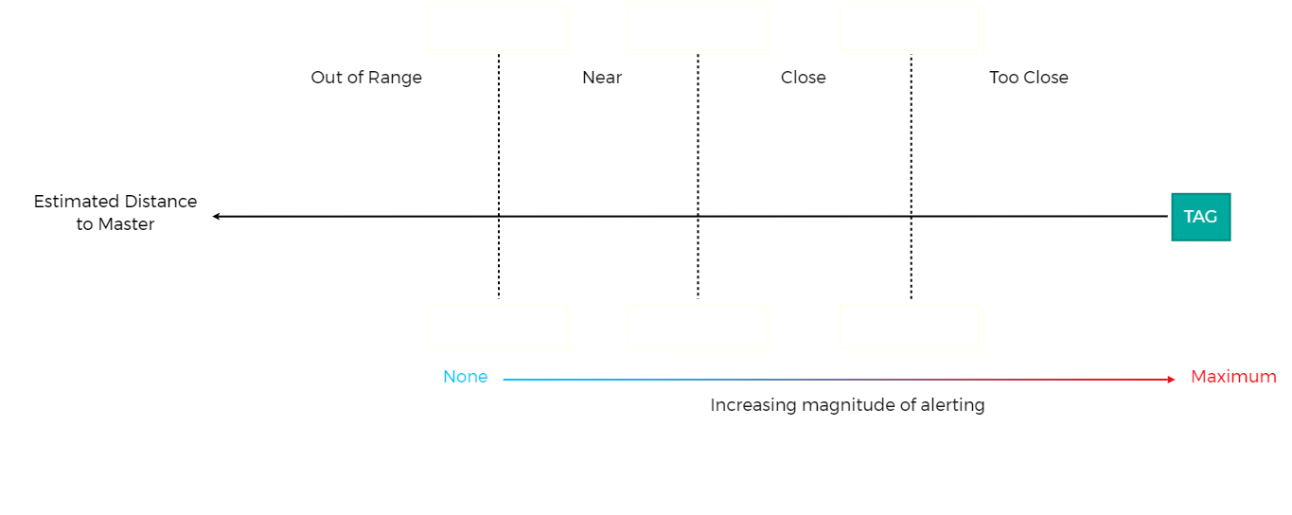

#### Prior Test Processes

There are three subsystems to be tested in the solution proposed for the project. These are the detection, control, and alerting subsystems. Up to this point, the detection system has been tested. The procedure followed during the tests of the detection subsystem, the results of tests, and the evaluation of test results concerning the requirements set for the detection subsystem are explained in the following sections.

##### Test Procedures

The tests mentioned in this part are the tests that were done before the presentation. The team selected various test setups to observe the RSSI values for different distances between the tag and the master unit. As explained before, the master unit sent a signal that triggered a response from the tag. The RSSI value of the received signal was measured using the built-in tools of the CC2640 microcontroller. These cases were selected to test the angle-dependence and material dependence of the system specifically. For these tests, we used a simple low-pass filter to eliminate some of the noise in our measurements. In each case, the distance was set to 20cm, 40cm, 60cm, 80cm & 100cm, and a sample was taken for 10s with a sampling frequency of 10Hz. Using this 100-sample data, a mean & standard deviation value was calculated to observe the system's precision for each case and distance. To compare the effectiveness of the low-pass filter, a sample was taken using the raw value of the RSSI measurement without any loss of line-of-sight. Each test case and the measured RSSI value from a specified distance will be explained in the table given in the “Test Results” part of the report.

##### Experiments

The determined test cases are:

1. “Normal”: The raw RSSI value is filtered & there is no object between the tag and the master unit. It is named as normal as it is assumed that the system would operate more reliably in such a case. Note that if not specified otherwise, all test cases used the filtered RSSI value.
2. “Chipboard”: A chipboard with a thickness of 2.5 cm was placed 10 cm away from the master unit, in between the tag and the master. This case was chosen to determine what changes a furniture-like obstruction would create.
3. “Metal”: A nonstandard iron object with a complicated shape was placed in the line of sight to evaluate its effect.
4. “Angle90”: The tag was rotated 90° on the same plane as the master unit to observe the effects of angle.
5. “Angle180”: Similarly, the tag was rotated 180° on the same plane as the master unit to observe the effects of angle.
6. “RawRSSI”: This case is simply the “Normal” case without filtering. It was created to observe what level of deviation we were getting from our measurements.

The photos of the tests made with the detection subsystem are shown in the following figures.

**Figure 3.9** *Photo of the setup* **Figure 3.10** *Another photo of the setup*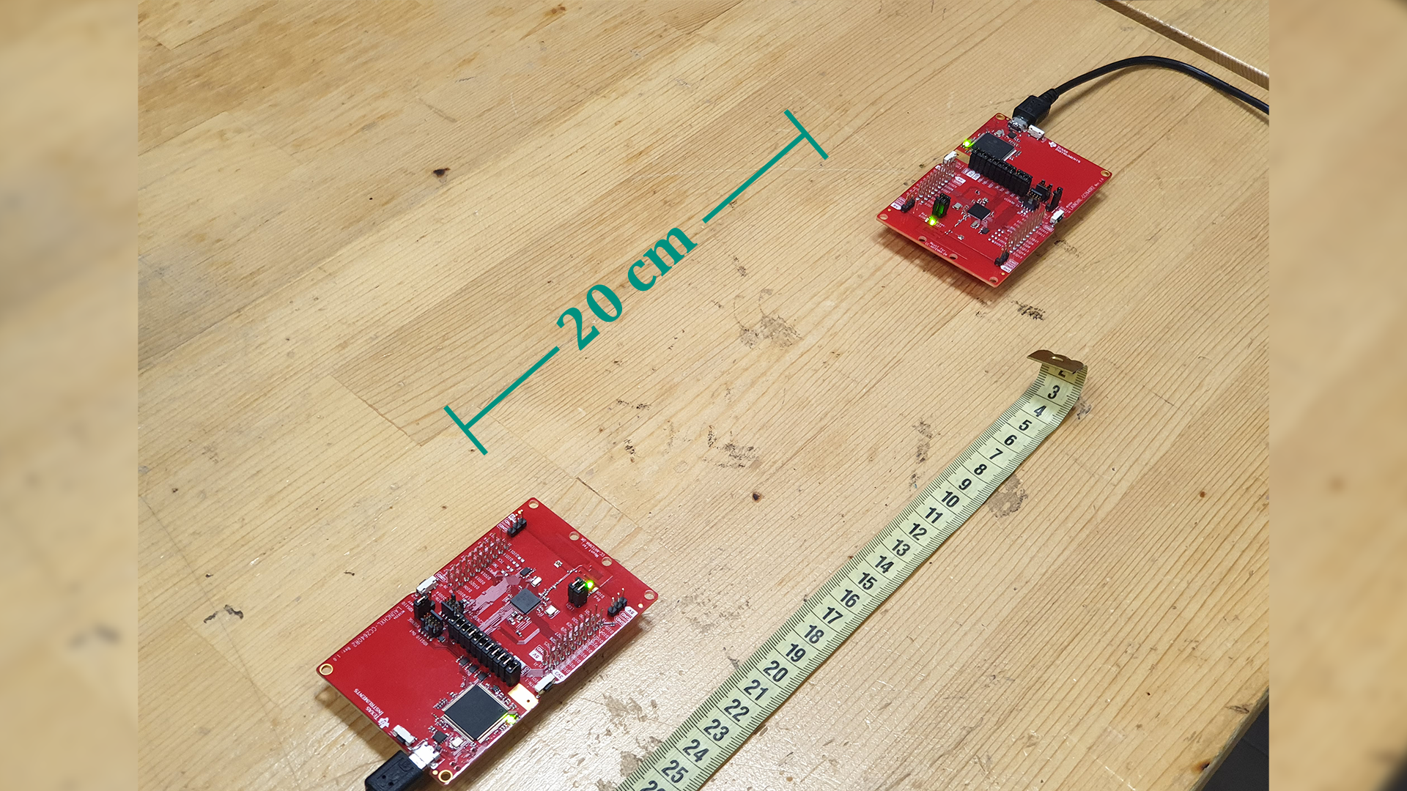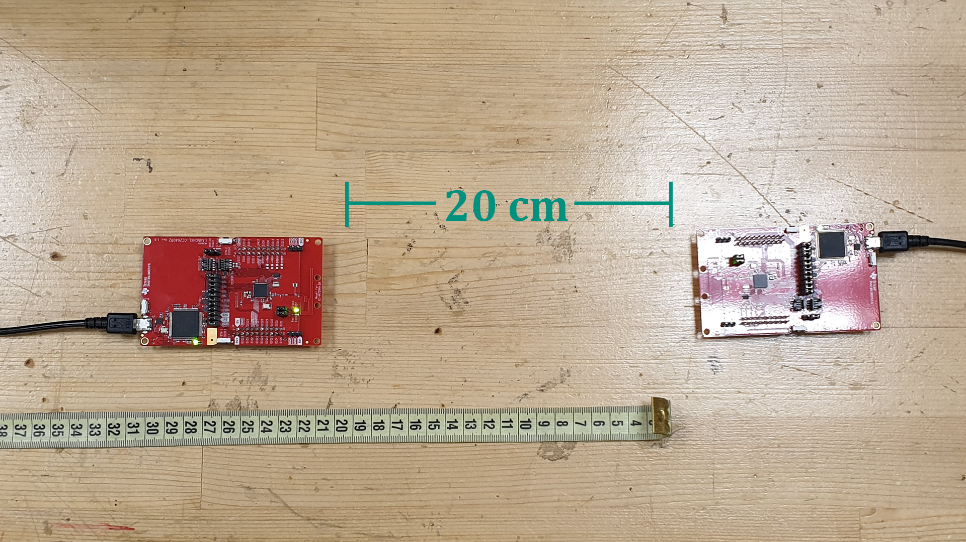

**Figure 3.11** *Normal case with 60cm* **Figure 3.12** *Non-Uniform Metal 40cm*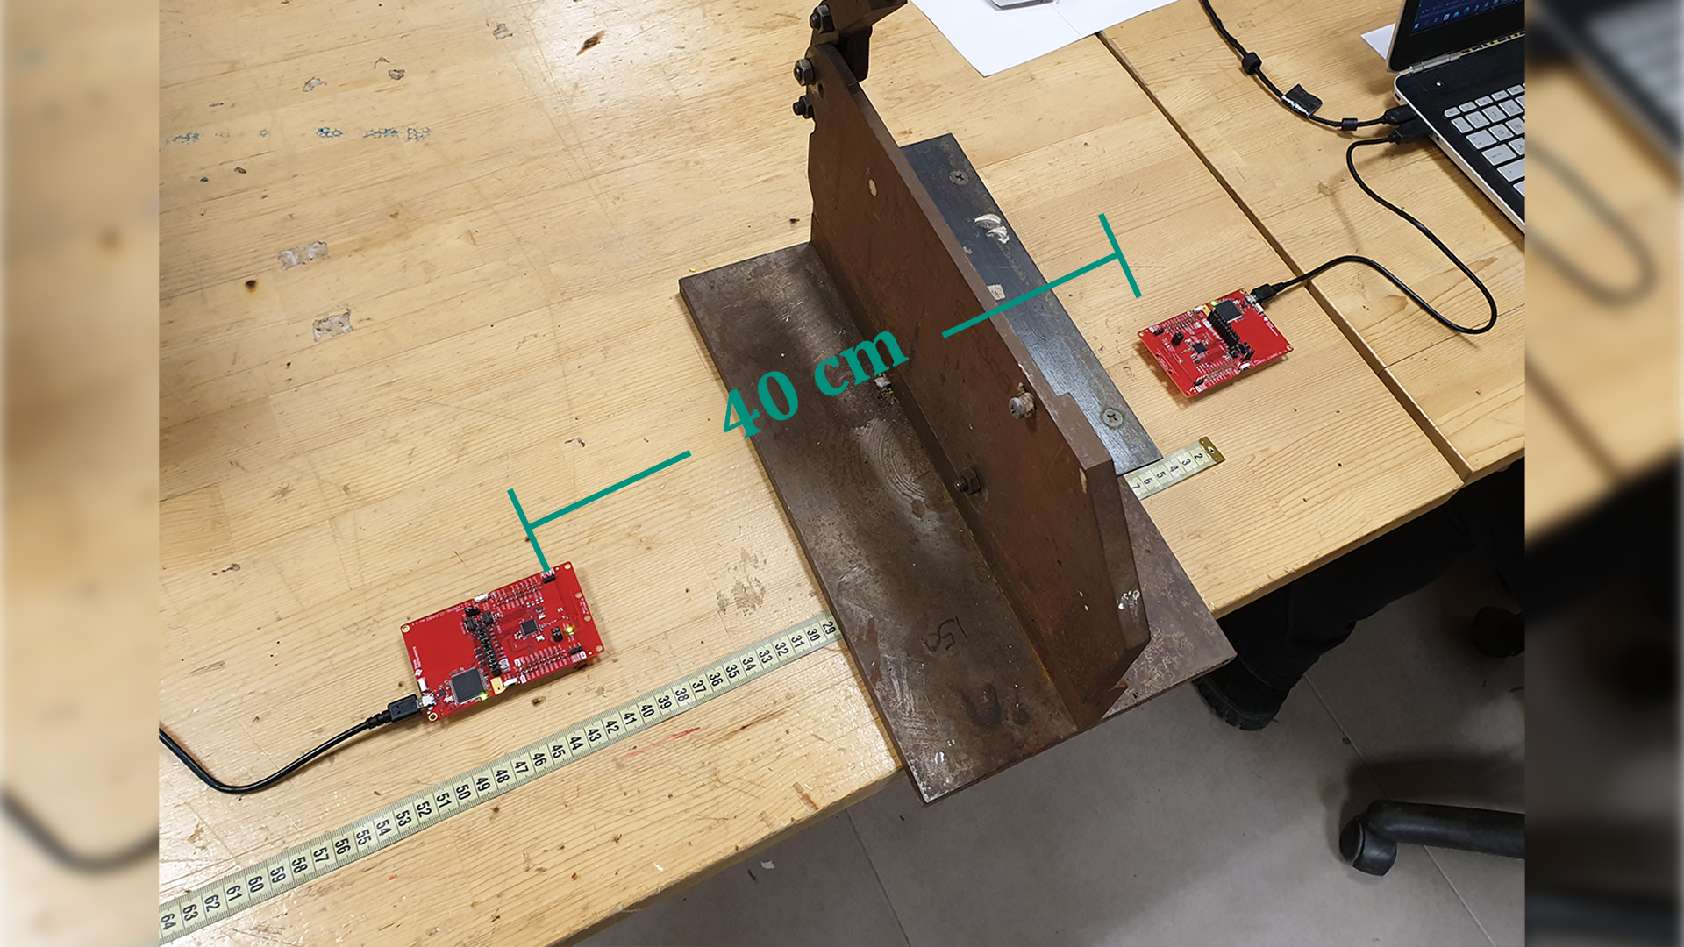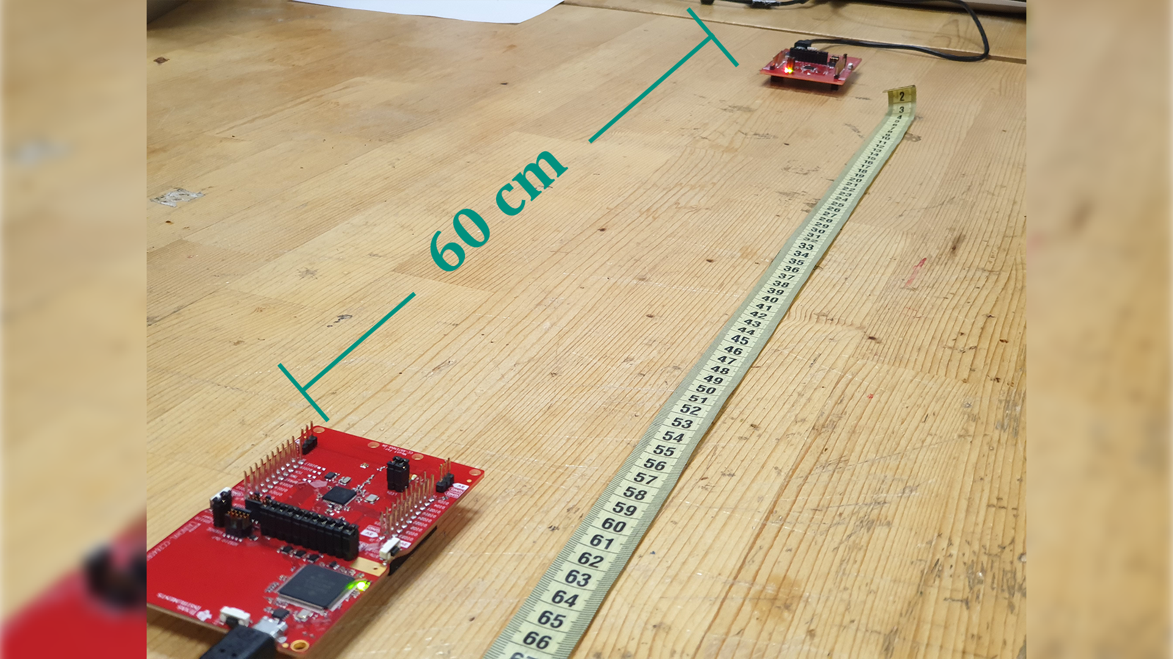

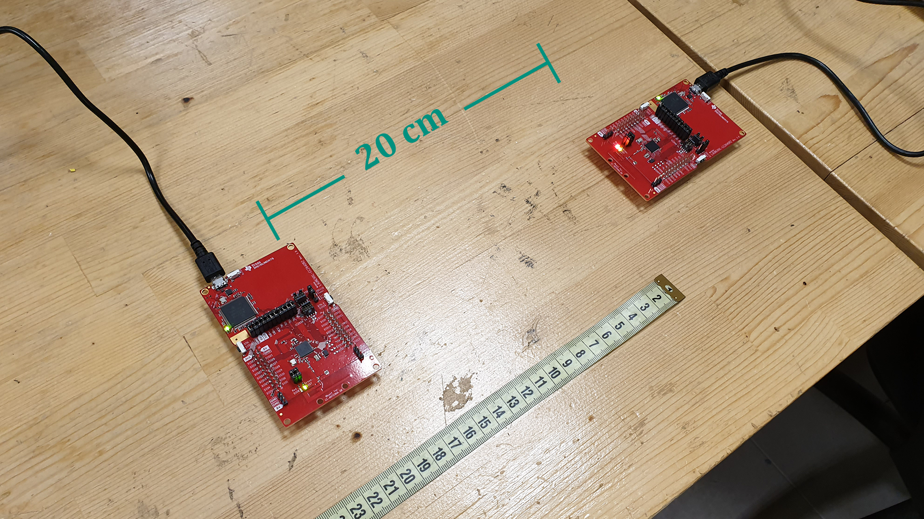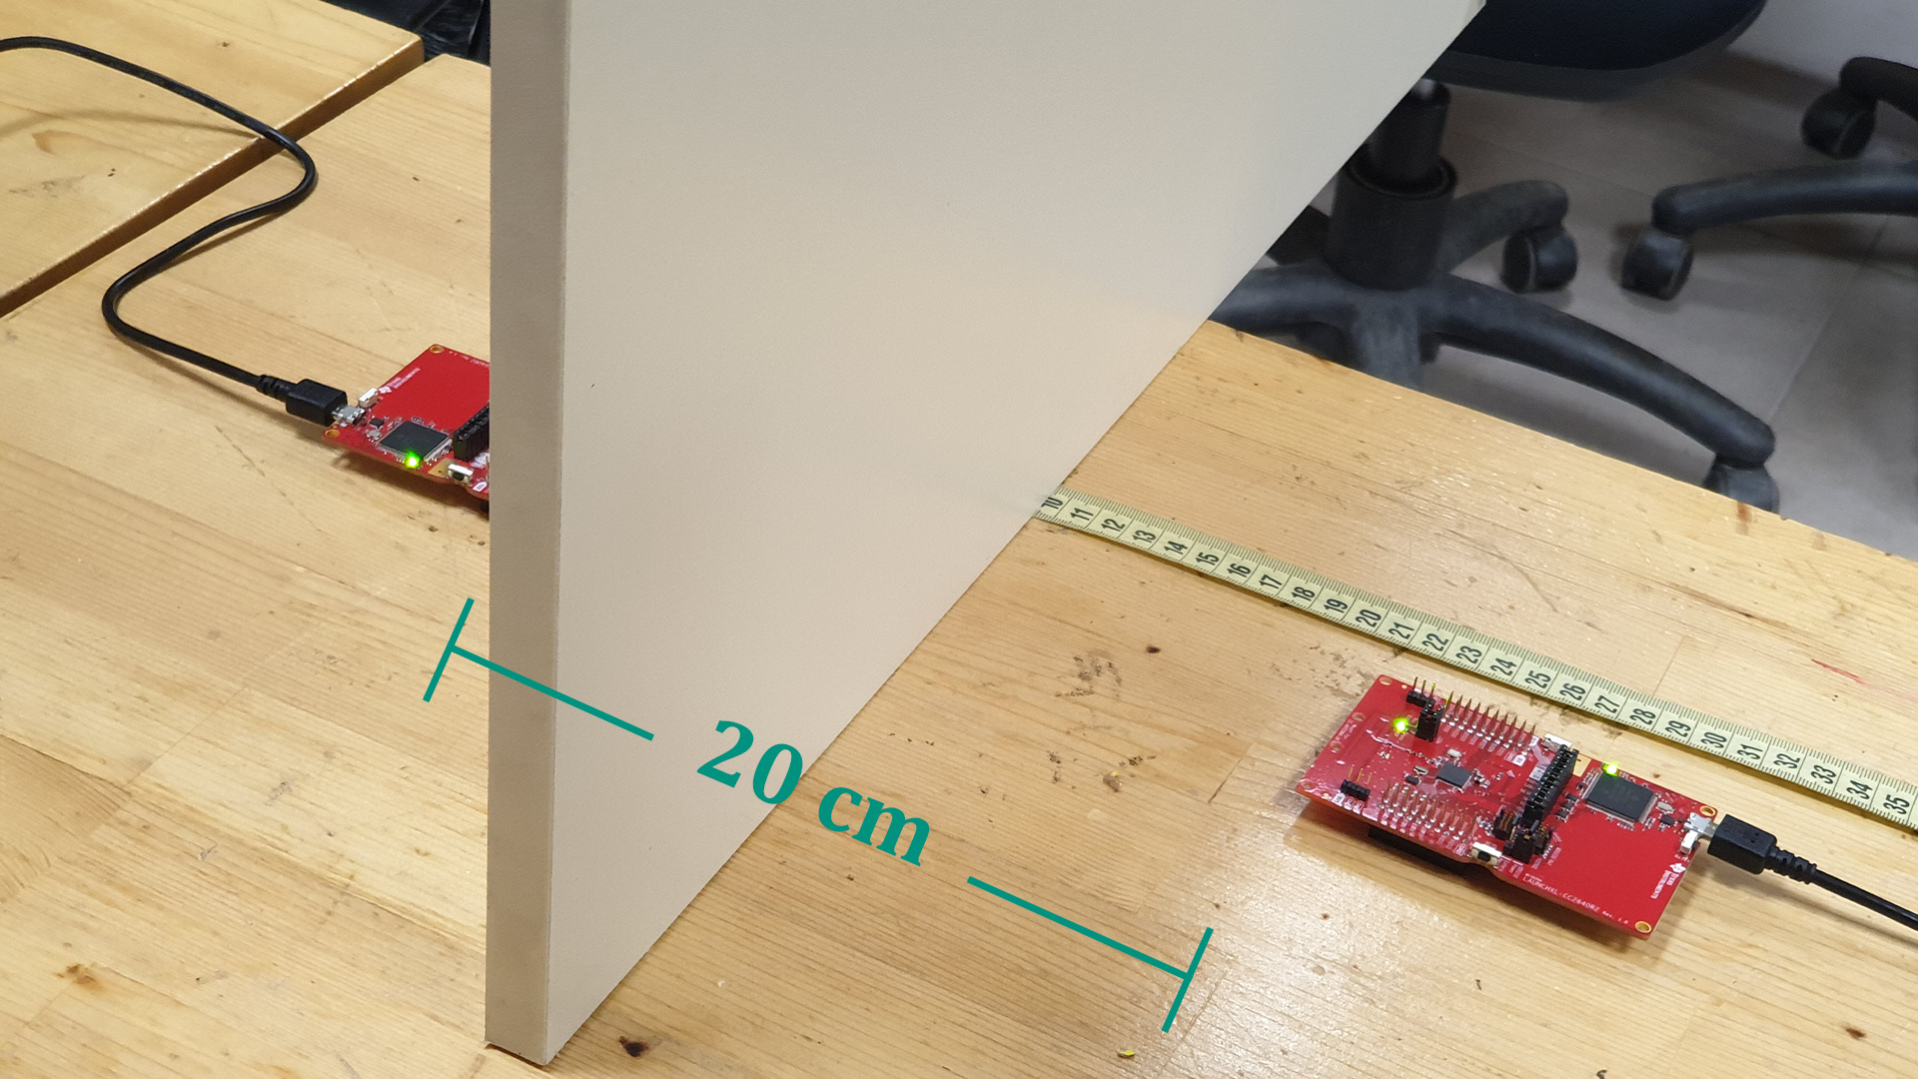

**Figure 3.13** *Clipboard 20cm* **Figure 3.14** *90° Angle 20cm*

##### Test Results

**Figure 3.15** *Test Results*

Note that the values colored in red were deemed to be unreliable as for each time they were sampled, the result changed by at most 30%, and because of this, they were treated as a failed measurement. A linear approximation of the normal case (filtered & unobstructed) is given below.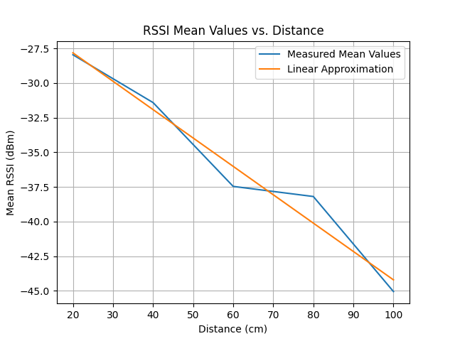

**Figure 3.16** *RSSI mean values vs. distance plot for the “Normal” case*

A linear approximation can be used due to the range of the distance we operated at. Since the range is much smaller than the expected maximum range of the transmitter unit, local values can be approximated linearly. For a larger range, this is invalid.

The linear approximation turns out to be $y (dBm) = -0.2048*x (cm) -23.726$. We would expect the result to be more correlated to the linear approximation in this short distance range. However, the practical application deviates from theoretical assumption since the medium of propagation is non-uniform in terms of its electromagnetic properties.

If we were to approximate the “Chipboard” case linearly, the resulting line would be $y (dBm) = -0.2487*x (cm) -19.138$. This was not expected as we thought that in the “Chipboard” case, the measured RSSI values would be lower for close distances. Our test results showed that in close proximity, the “Chipboard” case resulted in higher RSSI measurements, and as the distance increased to 100 cm, the measurements were below the “Normal” case. Note that the RSSI drop-off per distance is higher in the “Chipboard” case. As a result, the conclusion of “RSSI values would decrease faster if there is an obstruction” can be reached. However, we cannot conclude that an obstruction would imply lower RSSI readings.

The comparison of the cases “normal” (filtered & unobstructed) and “metal” (filtered & obstructed by an iron object) is given in the following plot.

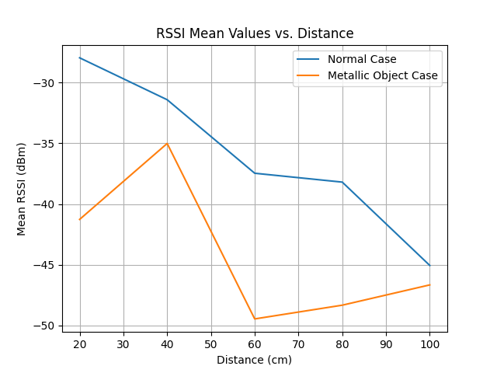

**Figure 3.17** *Comparison of the “Normal” case and the “Metal” case*

The existence of a metallic object in between the tag and the master unit changes the measurements by at most 47%. Moreover, the assumption of “RSSI will strictly decrease as distance increases” is not valid for the metallic object case.

The standard deviation of the samples taken in cases normal (filtered & unobstructed), raw (not filtered & unobstructed), and metal (filtered & obstructed by an iron object) are given below.

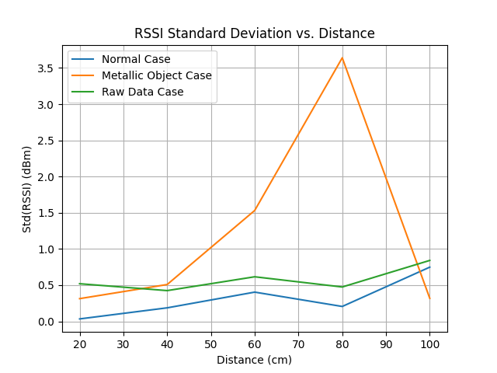

**Figure 3.18** *Comparison of standard deviation values for the given cases*

As you can see, the standard deviation value of the “metal” case is at most 15 times the “normal” case for the samples taken. This implies that the value of RSSI was comparatively more unstable compared to other cases.

If we compare the raw and filtered (named as normal) cases, as expected, the filter decreases the standard deviation.

For the angled cases (named “Angle90” & “Angle180” for 90° and 180° respectively) the samples were sensitive to minimal angle changes as a change of approximately 5-10° resulted in a change in the RSSI value of about 2-3 dBm. This made the team less confident about the validity of measurements as such small changes of angle cannot be determined reliably for each measurement.

As a simple demonstration, a simple distance calculation algorithm was implemented. The threshold distances were set as 40cm, 70cm & 100cm.

|  |  |  |
| --- | --- | --- |
| **Set Threshold Distance (cm)** | **Measured Threshold Distance (cm)** | **Error (%)** |
| 40 | 48 | 20 |
| 70 | 76 | 8.57 |
| 100 | 98 | 2 |

**Figure 3.19** *Table for the comparison of expected and measured distances*

The error is within our error margin. As the distance increases between the tag and the master unit, the proportional error increases in the test we have done. Since the error is lower in larger distances, using the more accurate measurement, an algorithm may be able to correct for the deviation at smaller distances assuming the pet starts moving from larger distances towards the tag.

### Requirements

* Proximity Sensing: The product, more specifically the detection subsystem, should be responsive to the distance between the master unit and the tags.
* Desired Range: The device should be able to operate inside the house.
* Accuracy: The distance estimation should be as close to reality as possible.
* Reaction Speed: The device should react to changes in the distance quickly.
* Cost: The product, and mainly the tags, should be cost-efficient.
* Size/Weight: The master unit should not weigh too much since it will be worn by an animal. The size should be small enough to be comfortable for the animal.
* Power Consumption: The power consumption of the device should allow it to last a long time without the need for a battery change.
* Safety: The device should not harm the animal and its surroundings.
* Aesthetics: The device should be pleasant to look at as the product will be used in the consumers’ houses and worn by their pets.

### Management

The management organization of the team, that is, the responsibilities of team members, the Gantt Chart to be used during the planning, estimated cost analysis, and deliverables are provided below.

#### Cost Analysis

**Figure 5.1** *Cost analysis table for the current setup*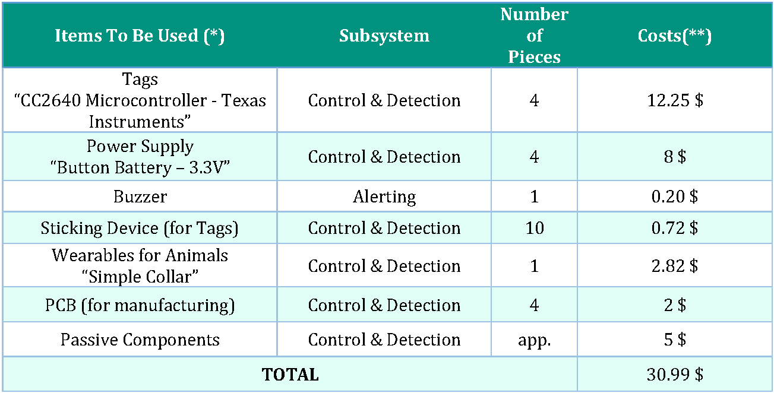

(*) (Expected Items) The equipment examined and used here may change according to our future research and test results. There may be some materials that can be used as extra or removed from there.

(**) Pricing is based on the known market value of the components (Robotistan, Alibaba, etc.). It may change according to the incoming hikes or discounts.

#### 

#### Power Analysis

There are three components/systems in the project that will consume power. These are,

* RF Communication Module in the CC2640 microcontroller
* The microcontroller itself
* The Buzzer in the master unit

For RF communication, the power consumption varies depending on the state of the communication at different time intervals. If there is a transmit or receive event every 1 second, then the current consumption can be estimated as 25 μA. Assuming 5V, this results in 0.125 mW of power.

For the buzzer, the current consumption can be estimated as 0.5 mA. Assuming the branch voltage is 5V, the power consumption will be 2.5 mW. Since the buzzer will not be constantly on, the average value should be considered. Assuming that the buzzer stays on for 1/10th of the total operation time, the average current value will be 50μA and the average power consumption will be 0.25 mW. This estimation assumes the animal does not stay in one of the forbidden zones for too long.

The microcontroller itself (excluding the RF communication core) consumes around 5μA. Assuming 5V for the operating voltage, the power consumption will be 0.025 mW.

The power distribution charts for the master and the tags are given below.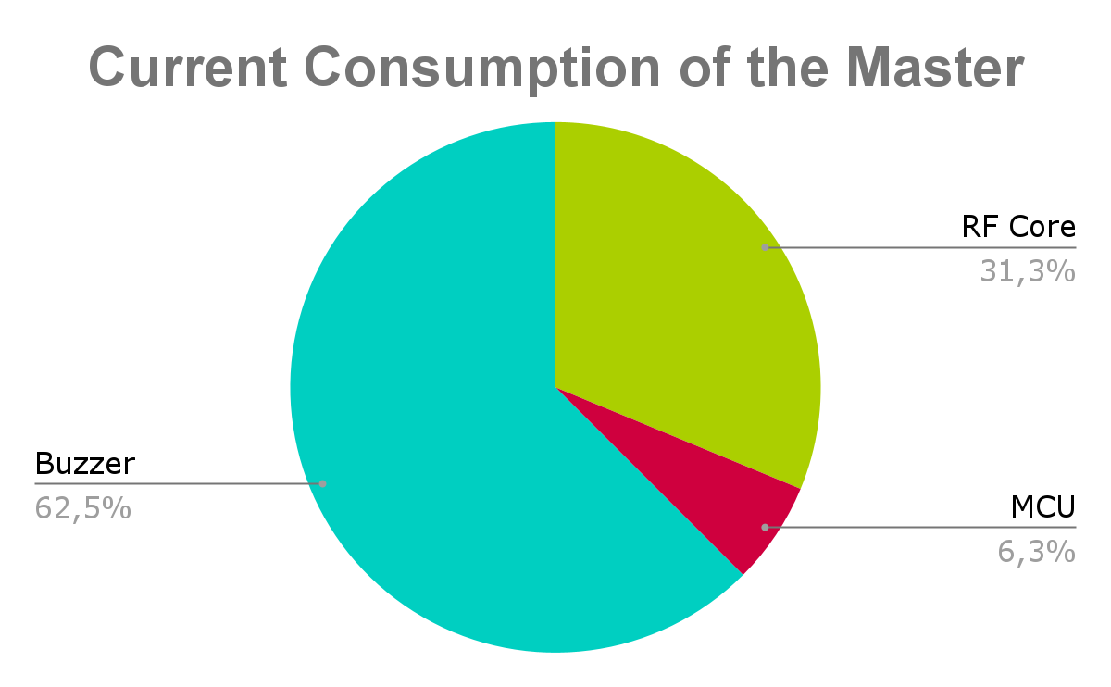

**Figure 5.2** *Cost analysis pie chart for the master unit*

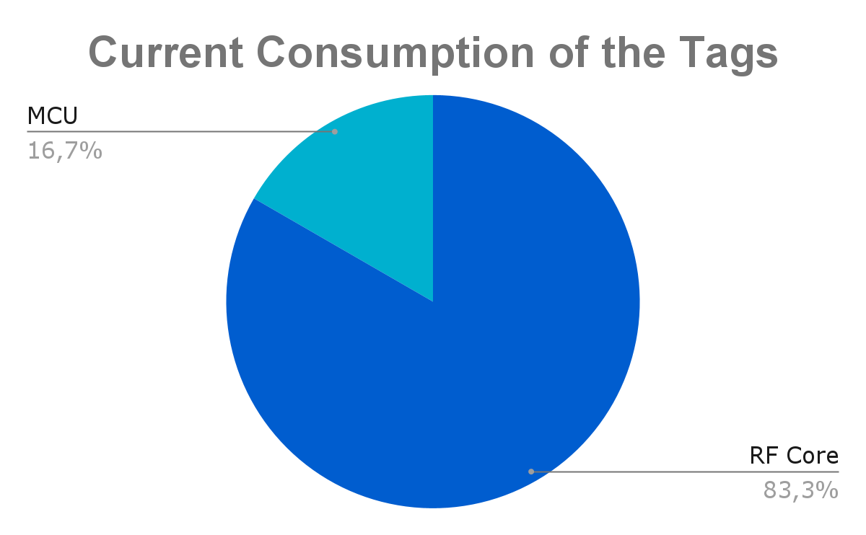

**Figure 5.3** *Cost analysis pie chart for the tags*

#### Deliverables

While determining our deliverables needs for a customer-oriented project, it was important for us to put a product that met the system requirements. For this, the following plans were made:

**Equipment Deliverables**

1. **Master Unit:** A structure suitable for the average size of the animal to be attached, wearable, able to stay in contact with the tags thanks to the kit it has on it and giving stimulation to the animal according to the signals it receives from the tags. On it, there is the microprocessor, antenna, and power supply feeding the card and buzzer.
2. **Tags:** Tags that the customer will place in the desired part of the house with a sticky apparatus for the restricted area and the prohibited doorway.

**Service and Technical Hardware Support**

1. **Warranty Certificate:** The device is guaranteed by Lambda Company for two years. In case of faulty use by the customer and the system is opened by any third party from outside, the warranty will be voided.
2. **User Manual:** A user-friendly document stating the device's initial setup, recommended usage patterns, and modes.

### Test Plans

There are three subsystems that make up the device, each of which needs to be tested. Of these, tests were carried out for the detection subsystem in the laboratory, and the results were also presented live during the demo. These tests demonstrated the acquisition of the RSSI value, which is the main metric the algorithm uses for estimating the distance between the master and the tag. However, there are more tests that need to be carried out to ensure that the device functions as desired. Some of these test plans are given below. The total point for the setup will be calculated. For a total score below 4, the setup will be reconsidered to increase the operability of the product.

#### Test Plan for Detection Subsystem

The whole system will be tested systematically in a variety of environments, mainly in different houses, to assess the precision of the detection subsystem. The following metric table will be used to evaluate the results.

|  |  |  |  |  |
| --- | --- | --- | --- | --- |
| **Std of RSSI** | 0.1 dBm | 0.2 dBm | 0.3 dBm | 0.5 dBm |
| **Point** | 3 | 2 | 1 | 0 |

**Figure 6.1** *Table showing the evaluation criteria for the detection subsystem*

#### Test Plan for Control Subsystem

For the control subsystem, many of the filtering approaches used previously, as well as the current approach, seem to be lacking in reaction speed. For this, the following table will be used to evaluate the reaction speed of the system.

|  |  |  |  |  |
| --- | --- | --- | --- | --- |
| **Reaction Time** | 0.1 s | 0.2 s | 0.5 s | 1 s |
| **Point** | 3 | 2 | 1 | 0 |

**Figure 6.2** *Table showing the evaluation criteria for the control subsystem*

### Compatibility Analysis of Subblocks

For the PCB implementation of the product, the design of the PCB antenna is crucial in order to obtain accurate RSSI readings. This is the main consideration in the integration of the detection subsystem and the control subsystem. In terms of compatibility, since the CC2640 microcontroller has an RF core, the compatibility of the detection and the control subsystem should not be a problem as the microcontroller was designed to be used in wireless communication applications. The electromagnetic signal received by the detection subsystem will be easily read by the control subsystem through the mentioned RF core.

For the alerting subsystem, the buzzer will be driven by a peripheral GPIO pin of the microcontroller. The operating voltage of an average buzzer can be supplied directly by a microcontroller. The connection between them is simply a digital output pin from the microcontroller. Hence, there should not be any compatibility issues related to the control subsystem and the alerting subsystem.

### Compliance with Requirements

The implementation was designed with the requirements given in mind. In this section, you will find how and why our design choices were made, and how each of them affects the system as a whole. These are to be supported through references made to the test procedures presented in a previous section, and the trade-offs that needed to be made in order to achieve the desired result.

In order to allow the master unit to sense the tag being in proximity, RF communication was preferred. This is because RF is virtually unaffected by (nonmagnetic) obstructions, and can be implemented efficiently in terms of cost and power consumption. Furthermore, it provides the range that is being looked for. For the microprocessor, TI’s SimpleLink series was preferred thanks to the embedded RF features that the microprocessors in the series provide. CC2640R2 specifically was preferred because it is the cheapest in the series while providing the desired performance. The microprocessor also has one of the lowest power consumption levels in the market, which is one of the qualities a consumer would look for in a smart wearable device.

Received signal strength indication (RSSI) is used to estimate the distance between the master unit and the tag. This is because other methods such as time-of-flight (ToF) are not suitable for close-range implementations such as ours. However, RSSI measurement can be quite noisy. As such, filtering was done in order to remove this noise and obtain as robust of measurement as possible. During the implementation of the filtering, two different filtering methods were experimented with. The LTA (long-term average) method, which implements a real-time low-pass filter, provided a very good reaction speed, although was lacking in terms of noise canceling. The Kalman filter method provided much better precision, but had a terrible reaction speed. As such, the two were combined to implement a watered-down real-time Kalman filter, using which we were able to achieve the desired levels of both reaction speed and precision.

Another important choice made was to design our own PCB. This will reduce the size and the cost of the device considerably, as well as make the device more pleasing aesthetically.

For the method of alerting, acoustic alerting through the use of a buzzer was chosen. This is because other methods such as electrical or mechanical were considered to be a bit too cruel.

**Figure 8.1** *Table showing the match between requirements and design decisions*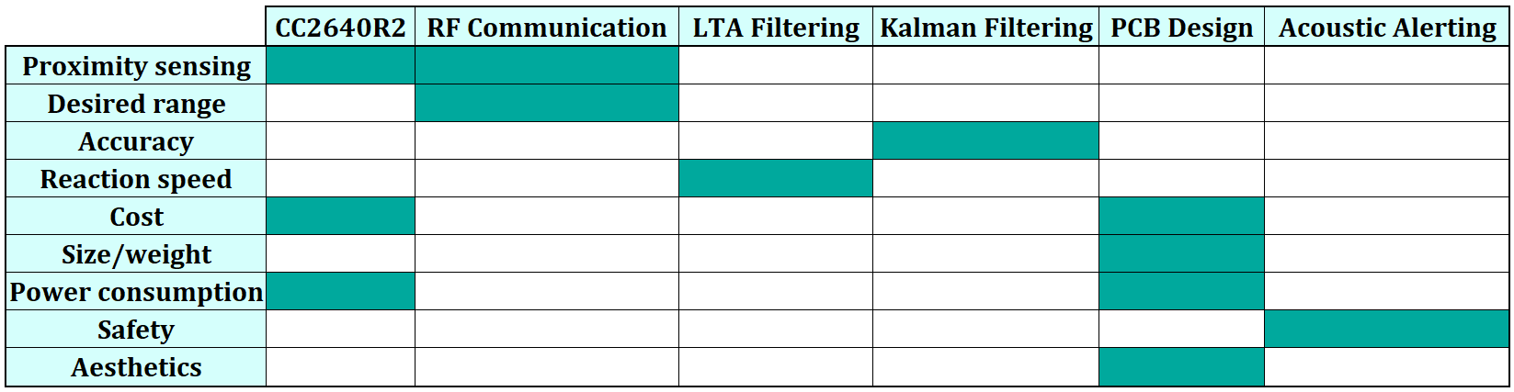

### Conclusion

The solution proposal that was settled upon for the given problem was discussed in detail. This approach uses RF waves to communicate between two devices (master and tag). Using the **RSSI measurement**, the master calculates an estimate of the distance between itself and the tag. The estimate is then used to alert the wearer of their proximity level. In the case where the two units face each other perpendicularly with no blockage, the prototype is able to calculate the closeness between itself and the tag with reasonable accuracy, which was verified through the tests conducted. Cases when there is an obstacle or when devices are in different orientations were also investigated and identified as potential sources of decreased accuracy.

The system, and the subsystems making up the system, were explained one by one in detail, including how they work, the design choices made, and the difficulties faced during their design, as well as how they interact with each other. These were followed by the previously conducted test procedures and their results, along with the analysis of these results identifying the strong and weak points of the current design, and ideas on how to improve the product further. Also, the expected cost, power consumption, and deliverables of the project were given.

The progress made on the implementation was also given, along with the problems encountered until now and contingency plans to mend those problems. Future stages of the development planned were talked about, such as implementing the buzzer for the alerting subsystem, designing and switching the prototype to a PCB design, as well as test procedures to be carried out to validate the design choices made. The Gantt chart detailing the timetable of these plans were also provided in the Appendix.

### References

[1]https://www.wouterbulten.nl/blog/tech/kalman-filters-explained-removing-noise-from-rssi-signals/

[2]https://www.researchgate.net/publication/261156571_Real_time_RSSI_error_reduction_in_distance_estimation_using_RLS_algorithm

[3]https://www.researchgate.net/publication/317150846_Radio_Frequency-Based_Indoor_Localization_in_Ad-Hoc_Networks

### Appendix

#### Gantt Chart



 